# User Views and Data Cross-Reference Table

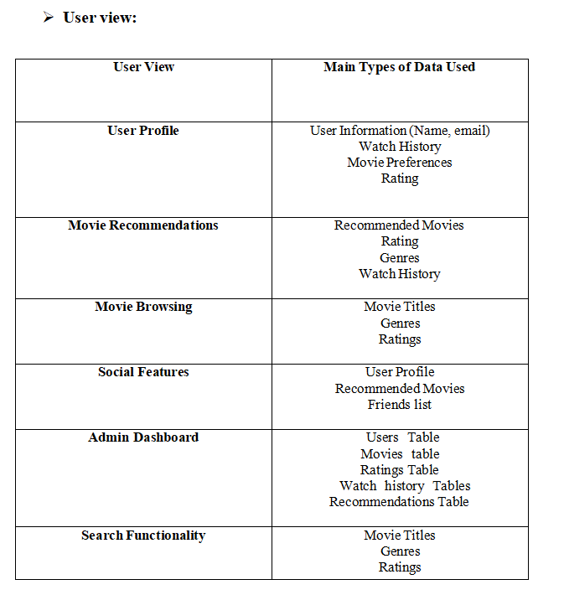

## Cross-Reference Table for User Views and Data